Question 1: MST in Distributed Systems - Beginner-Friendly Explanation

What is a Minimum Spanning Tree (MST)?
Let's start with a simple example:
Imagine you have 4 cities: A, B, C, D
You want to connect them with roads so that:
- You can travel from any city to any other city
- You use the minimum total road length

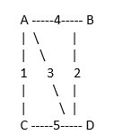
Cities with possible roads and costs:
Roads available:
A-B: 4 km
A-C: 1 km
A-D: 3 km
B-D: 2 km
C-D: 5 km

Question: Which roads should you build?
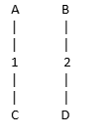
Answer (MST):
Build: A-C (1), B-D (2), A-D (3)
Total: 6 km

Why these 3 roads?
- They connect all 4 cities
- Total cost is minimum (6 km)
- No cycles (you don't go in loops)
This is a Minimum Spanning Tree!

What does "Distributed" mean?
Normal MST:
- One computer does all the work
- Looks at all roads at once
Distributed MST:
- Multiple computers work together
- Each computer knows about only PART of the graph
- They need to communicate to find the answer
Example:
Computer 1 knows: Computer 2 knows:
Cities A, B Cities C, D
Roads: A-B, A-C, A-D Roads: B-D, C-D, A-C

They need to TALK to each other to find the complete MST!

The Simple Algorithm (Borůvka's)
Let me explain it like you're connecting groups of friends:
Starting Point:
Everyone is alone (each person is their own group)
Round 1:
A (alone) B (alone) C (alone) D (alone)

Round 1: Everyone finds their closest friend
Each person looks for the shortest connection to someone OUTSIDE their group:
A looks around:
- B is 4 away
- C is 1 away ← CLOSEST!

- D is 3 away
A picks: C

B looks around:
- A is 4 away
- D is 2 away ← CLOSEST!
B picks: D

C looks around:
- A is 1 away ← CLOSEST!
C picks: A

D looks around:
- B is 2 away ← CLOSEST!
D picks: B
Result: Connect A-C and B-D
After Round 1:
(A + C group) (B + D group)

Round 2: Groups find closest connection to other groups
Now we have 2 groups. Each group looks for shortest connection:
Group {A,C} looks for connections to {B,D}:
- A-B: 4
- A-D: 3 ← SHORTEST!
- C-D: 5

Group {B,D} looks for connections to {A,C}:
- B-A: 4
- D-A: 3 ← SHORTEST!
- D-C: 5
Result: Connect A-D (or D-A, same thing)
After Round 2:
(A + B + C + D - everyone connected!)
DONE!
Our MST: A-C (1), B-D (2), A-D (3) = Total 6

How This Works on Multiple Computers
Imagine 2 computers:
Computer 1 handles:
- Cities A, B
Computer 2 handles:
- Cities C, D
Round 1:
Computer 1's work:
A finds closest: C (distance 1) - but C is on Computer 2!
B finds closest: D (distance 2) - but D is on Computer 2!
Computer 2's work:
C finds closest: A (distance 1) - but A is on Computer 1!
D finds closest: B (distance 2) - but B is on Computer 1!
Communication:
Computer 1 tells Computer 2: "I want to connect A-C and B-D"
Computer 2 tells Computer 1: "I want to connect C-A and D-B"

They agree! Add edges: A-C and B-D to MST
Round 2:
Both computers realize there are now 2 groups: {A,C} and {B,D}
Computer 1: "The cheapest way to connect groups is A-D (cost 3)"
Computer 2: "I agree, D-A (cost 3)"

Add edge: A-D to MST
Algorithm complete!

The Union-Find Helper
This is like a notebook that keeps track of "who's in which group"
Initial notebook:
A is in group A
B is in group B
C is in group C
D is in group D
After connecting A-C:
A is in group A
B is in group B
C is in group A ← C joined A's group
D is in group D
After connecting B-D:
A is in group A
B is in group B
C is in group A
D is in group B ← D joined B's group
After connecting A-D:
A is in group A
B is in group A ← Everyone in same group!
C is in group A
D is in group A
This "notebook" is Union-Find - it helps us quickly answer:
- "Are A and C in the same group?" → Yes!
- "Should I add this edge?" → Only if it connects different groups

Real-World Example: Sensor Networks
The Problem:
Imagine you have 100 temperature sensors in a building:
Floor 1: Sensors 1-20
Floor 2: Sensors 21-40
Floor 3: Sensors 41-60
...
Issue: Sensors near each other show almost the SAME temperature!
Sensor 1: 22.1°C
Sensor 2: 22.3°C ← Very similar!
Sensor 3: 22.2°C ← Very similar!
Question: Do we really need all 100 sensors? Can we use fewer?

The Solution Using MST:
Step 1: Measure how similar each pair of sensors is
Sensor 1 and Sensor 2: 95% similar
Sensor 1 and Sensor 50: 30% similar (different floors!)
Step 2: Make a graph
- Each sensor = a dot (node)
- Connect sensors with lines (edges)
- Line thickness = how DIFFERENT they are (inverse of similarity)
Thin line = very similar (redundant)
Thick line = very different (useful)
Step 3: Find MST
- This keeps sensors that are DIFFERENT from each other
- Removes redundant sensors
Result:
Before: 100 sensors
After MST: 15 sensors (one per region)
Information kept: 95%
Cost saved: 85%!

Question 2: Range-Sum Queries for Feature Stores - Beginner-Friendly Explanation
What is the Problem?
Imagine This Scenario:
You're building a system for an e-commerce site (like Amazon) that tracks user activity:
User 1 clicked 5 products today
User 2 clicked 3 products today
User 3 clicked 8 products today
User 4 clicked 2 products today
...
User 1000000 clicked 1 product today
Questions you need to answer FAST:
- "How many total clicks from User 10 to User 100?"
- "How many clicks from User 500 to User 5000?"
- User 42 just clicked again - update their count!
Challenge:
- You have MILLIONS of users
- Queries come in constantly (thousands per second)
- Data keeps updating in real-time
- You need answers in milliseconds!

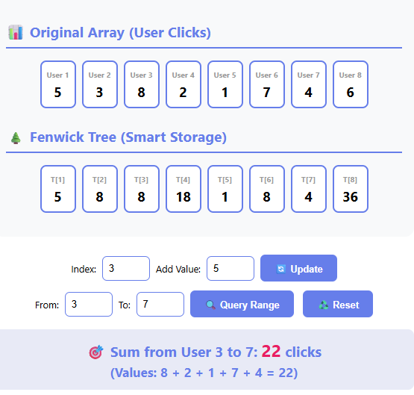
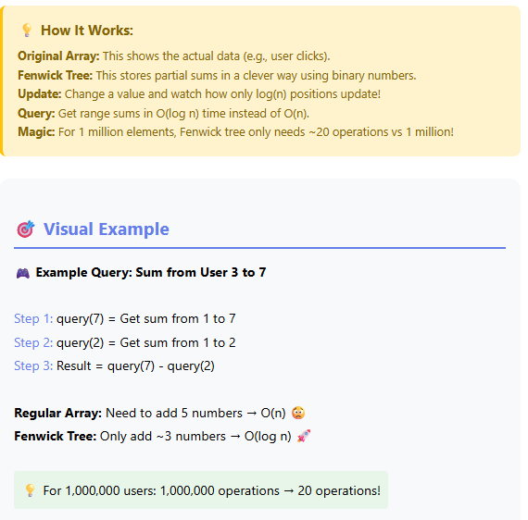

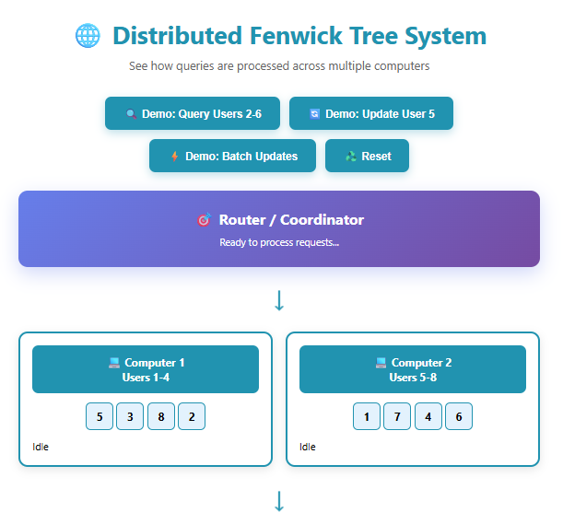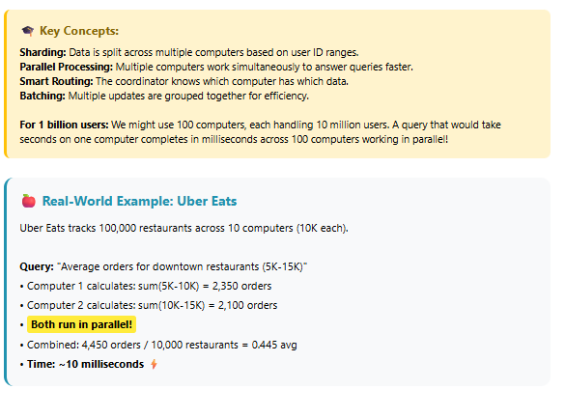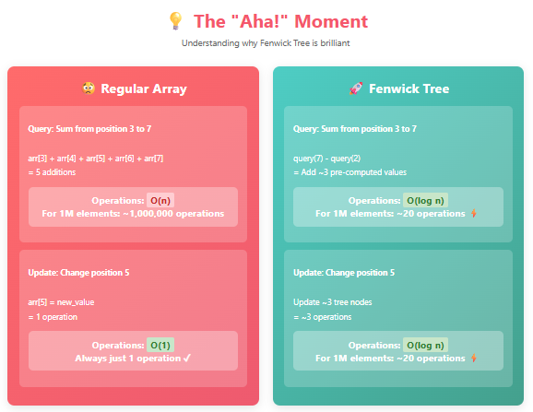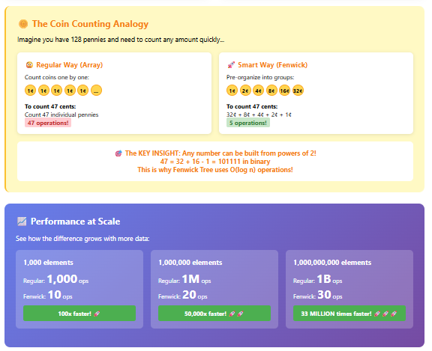
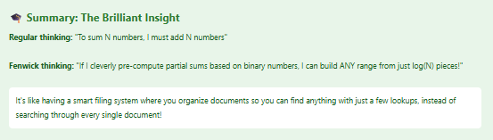

Question 3: Splay Trees for Model Caching - Beginner-Friendly Explanation
What is the Problem?
Imagine This Scenario:
You work at Netflix. You have 1000 different ML models:
Model 1: Recommends action movies
Model 2: Recommends comedies
Model 3: Recommends documentaries
...
Model 1000: Recommends kids shows
The Challenge:
- Models are BIG (100 MB each)
- Can't keep all in memory (would need 100 GB!)
- Loading from disk is SLOW (50 milliseconds)
- Users want predictions FAST (under 10 ms)
What you need:
- Keep only 10 most-used models in memory (cache)
- When someone asks for a model:
  - If it's in cache → instant! (1 ms)
  - If not in cache → load from disk (50 ms)
The million-dollar question: Which 10 models should you keep in memory?

The Caching Problem
Let's start with a smaller example: You can only keep 3 models in memory.
Scenario 1: Simple Pattern
Users request models in this order:
A, B, C, A, B, C, A, B, C, A, B, C...
(repeating pattern)
What happens:
Request A → Load A into cache [A]
Request B → Load B into cache [A, B]
Request C → Load C into cache [A, B, C]
Request A → Already in cache! Fast!
Request B → Already in cache! Fast!
Request C → Already in cache! Fast!
Perfect! All requests after the first 3 are fast.

Scenario 2: One Popular Model
Users request models in this order:
A, A, A, A, A, B, A, A, A, C, A, A, A...
(Model A is requested 90% of the time)
Ideal cache: Keep A always, swap B and C as needed
What we want:
- Model A should be "easy to find" (fast access)
- Models B and C can be "harder to find" (they're rare)

Solution 1: LRU Cache (The Simple Way)
What is LRU?
LRU = Least Recently Used
Rule: When cache is full, remove the model you haven't used in the longest time.
Visual Example:
Cache can hold 3 models. Currently empty: [ ]

Request A → Add A: [A]
Request B → Add B: [A, B] (A is older)
Request C → Add C: [A, B, C] (A is oldest)
Request D → Cache full! Remove A (oldest): [B, C, D]
Request A → Need to load A again: [C, D, A] (B removed)
Request B → Need to load B again: [D, A, B] (C removed)
How LRU Works (Like a Line):
Think of it like people waiting in line:
Most Recent → Least Recent
[D] → [C] → [B] → [A]

When you use D again, it goes to the front:
[D] → [B] → [A] → [C] is kicked out!

Solution 2: Splay Tree (The Adaptive Way)
What is a Splay Tree?
Splay Tree = Self-adjusting Binary Search Tree
Magic property: When you access an item, it automatically moves to the top!
Why is this cool?
- Frequently accessed items "float" to the top
- They become faster to access next time
- It adapts to your access patterns automatically!

Binary Search Tree Basics (Quick Refresher):
A tree where:
- Each node has a value
- Left child < Parent < Right child
Example BST:
5
/ \
3 7
/ \ \
1 4 9

To find 9: Start at 5 → go right to 7 → go right to 9 (3 steps)
To find 1: Start at 5 → go left to 3 → go left to 1 (3 steps)
Problem: If you access 9 a lot, you always take 3 steps!

Splay Tree Magic:
After accessing 9, the tree reorganizes itself:
Before accessing 9:
5
/ \
3 7
/ \ \
1 4 9

After accessing 9 (splay operation):
9
/
7
/
5
/
3
/ \
1 4

Now 9 is at the top! Next access to 9 = instant (1 step)!

How Splaying Works (The Rotations):
Think of it like reorganizing boxes:
Before:
Top box: A
Middle box: B
Bottom box: C (you want this!)
After one rotation:
Top box: B
Middle box: C (closer!)
Bottom box: A
After another rotation:
Top box: C (got it!)
Middle box: B
Bottom box: A

Three Types of Splay Rotations:
1. Zig (Single Rotation) - When node is one level below root
Before: After:
P N
/ \
N → P
2. Zig-Zig (Double Rotation) - When node and parent are both left (or both right) children
Before: After:
G N
/ / \
P → A P
/ \
N G
/
A
3. Zig-Zag (Double Rotation) - When node goes left then right (or right then left)
Before: After:
G N
/ / \
P → P G
\
N

Splay Tree vs LRU: Visual Comparison
Scenario: Access pattern A, A, A, A, B, A, A, A, C, A, A, A
LRU Cache (capacity 3):
Step 1: Access A → [A]
Step 2: Access A → [A] (already there, move to front)
Step 3: Access A → [A] (already there)
...
Step 5: Access B → [A, B]
...
Step 9: Access C → [A, B, C]
Step 10: Access A → [A, B, C] (just move A to front)

All accesses to A after initial load: O(1) constant time
Structure is fixed: just a list
Splay Tree:
Step 1: Access A → A becomes root
Tree:
A

Step 2: Access A → A stays at root (already there)
Step 5: Access B → B becomes root, A moves down
Tree:
B
/
A

Step 6: Access A → A splays back to root!
Tree:
A
\
B

After many accesses to A, A stays near the top
Tree adapts to show A is popular!

When is Splay Tree BETTER than LRU?
Advantage 1: Adapts to Frequency AND Recency
LRU only cares about recency:
Pattern: A, B, C, D, E, F, G, A

LRU thinking: "A is old, kick it out"
Reality: Maybe A is used every 10 minutes and is actually important!
Splay Tree cares about both:
If A is accessed frequently, it stays near the root
Even if you access B, C, D, E occasionally,
A won't go far because it keeps splaying back up!

Advantage 2: No Fixed Capacity
LRU:
Capacity = 10 models
If you need 11th model, you MUST remove one
Even if you have free memory!
Splay Tree:
All models stay in tree
Frequently accessed ones are fast (near root)
Rarely accessed ones are slow (deep in tree)
No hard eviction needed!

Advantage 3: Working Set Theorem
Mathematical property: If you repeatedly access the same K models:
LRU: Each access is O(1) if K ≤ capacity
Splay: Each access is O(log K) amortized

Example:
- You use 5 models regularly: A, B, C, D, E
- Occasionally access others
- Splay tree: The 5 models stay near top = O(log 5) ≈ 2-3 steps
- LRU: O(1) but must set capacity ≥ 5
Splay advantage: You don't need to know K in advance!

When is Splay Tree WORSE than LRU?
Problem 1: Uniform Access Pattern
Pattern: Every model accessed equally
Requests: A, B, C, D, E, A, B, C, D, E, A, B...
(round-robin)

LRU: If capacity ≥ 5, all accesses are O(1)

Splay Tree: Every access causes rotations!
- Access A → rotate A to top
- Access B → rotate B to top (A moves down)
- Access C → rotate C to top (B moves down)
- ...

Wasted work! Tree keeps reorganizing for no benefit

Problem 2: Adversarial Pattern
Pattern: Intentionally designed to hurt splay tree
Requests: Access deepest node, then second-deepest, then...

Tree structure forces O(n) worst case:
Depth 4: D
Depth 3: C
Depth 2: B
Depth 1: A

Access D → O(4) rotations
Access C → O(3) rotations
Access B → O(2) rotations
Access A → O(1) rotation

Total: O(n²) for n accesses

LRU: Still O(1) per access

Problem 3: High Concurrency
Problem: Multiple users accessing models simultaneously
LRU: Simple lock on the list
- User 1 gets model A
- User 2 waits a tiny bit
- User 2 gets model B
Quick unlock!

Splay Tree: Rotation requires exclusive lock
- User 1 accesses A → tree rotates (LOCK entire tree)
- User 2 wants B → WAITS for rotation to finish
- User 3 wants C → WAITS
- User 4 wants D → WAITS

With 1000 concurrent users → huge bottleneck!

Problem 4: Strict Latency Requirements
Example: Need predictions under 1 millisecond
LRU:
- HashMap lookup: 0.0001 ms
- List update: 0.0001 ms
- Total: 0.0002 ms Predictable!

Splay Tree:
- Search: 0.001 - 0.01 ms (depends on tree depth)
- Rotation: 0.001 - 0.005 ms (depends on case)
- Total: 0.002 - 0.015 ms Variable!

Even though average is fine, the VARIABILITY is a problem
Some requests take 10x longer than others!

